Discovery of conjugation
Do bacteria possess any processes similar to sexual reproduction and recombination? The question was answered in 1946 by the elegantly simple experimental work of Joshua Lederberg and Edward Tatum, who studied two strains of Escherichia coli with different nutritional requirements. Strain A would grow on a minimal medium only if the medium were supplemented with methionine and biotin; strain B would grow on a minimal medium only if it were supplemented with threonine, leucine, and thiamine. Thus, we can designate strain A as met⁻ bio⁻ thr⁺ leu⁺ thi⁺ and strain B as met⁺ bio⁺ thr⁻ leu⁻ thi⁻. Figure 7-2a displays in simplified form the concept of their experiment. Here, strains A and B are mixed together, and some of the progeny are now wild type, having regained the ability to grow without added nutrients. Figure 7-2b illustrates their experiment in more detail.
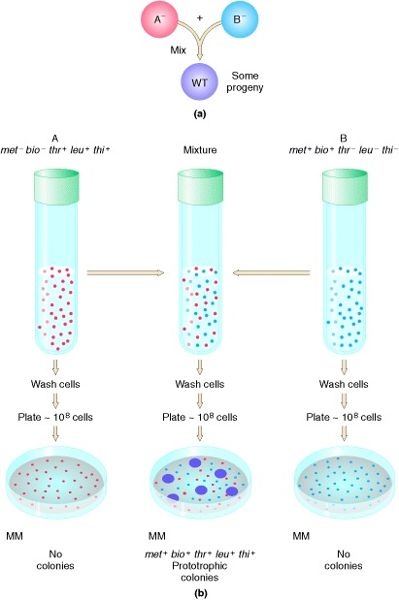

Figure 7-2
Demonstration by Lederberg and Tatum of genetic recombination between bacterial cells. Cells of type A or type B cannot grow on an unsupplemented (minimal) medium (MM), because A and B each carry mutations that cause the inability to synthesize constituents needed for cell growth. When A and B are mixed for a few hours and then plated, however, a few colonies appear on the agar plate. These colonies derive from single cells in which an exchange of genetic material has occurred; they are therefore capable of synthesizing all the required constituents of metabolism.
Reference:
An Introduction to Genetic Analysis. 7th edition.
Griffiths AJF, Miller JH, Suzuki DT, et al.
New York: W. H. Freeman; 2000.
Lederberg and Tatum plated bacteria into dishes containing only unsupplemented minimal medium. Some of the dishes were plated only with strain A bacteria, some only with strain B bacteria, and some with a mixture of strain A and strain B bacteria that had been incubated together for several hours in a liquid medium containing all the supplements. No colonies arose on plates containing either strain A or strain B alone, showing that back mutations cannot restore prototrophy, the ability to grow on unsupplemented minimal medium. However, the plates that received the mixture of the two strains produced growing colonies at a frequency of 1 in every 10,000,000 cells plated (in scientific notation, 1 × 10⁻⁷). This observation suggested that some form of recombination of genes had taken place between the genomes of the two strains to produce prototrophs

Requirement for physical contact
It could be suggested that the cells of the two strains do not really exchange genes but instead leak substances that the other cells can absorb and use for growing. This possibility of “cross feeding” was ruled out by Bernard Davis. He constructed a U-tube in which the two arms were separated by a fine filter. The pores of the filter were too small to allow bacteria to pass through but large enough to allow easy passage of the fluid medium and any dissolved substances (Figure 7-3). Strain A was put in one arm; strain B in the other. After the strains had been incubated for a while, Davis tested the content of each arm to see if cells had become able to grow on a minimal medium, and none were found. In other words, physical contact between the two strains was needed for wild-type cells to form. It looked as though some kind of gene transfer had taken place, and genetic recombinants were indeed produced.
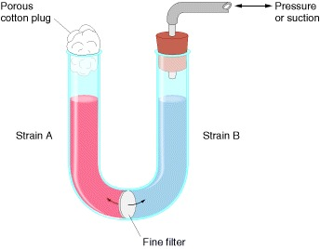

Figure 7-3
Experiment demonstrating that physical contact between bacterial cells is needed for genetic recombination to take place. A suspension of a bacterial strain unable to synthesize certain nutrients is placed in one arm of a U-tube. A strain genetically unable to synthesize different required metabolites is placed in the other arm. Liquid may be transferred between the arms by the application of pressure or suction, but bacterial cells cannot pass through the center filter. After several hours of incubation, the cells are plated, but no colonies grow on the minimal medium.

